Video-assisted Thoracoscopic Pericardial Window for Massive Pericardial Effusion: South Egypt Experience
Mohamed Abdel Bary ¹, Khaled M. Abdel-aal ², Ramadan Ghaleb Mohamed³ , Ahmed M. Abdel-maboud⁴, Abdelhady Ahmad-Helmy Abdelhady⁴
- Lecturer of cardiothoracic surgery, South valley university
- Ass. Prof. of cardiothoracic surgery, Sohag university
- Lecture of cardiology, Aswan university
- Lecturer of anaesthesia and ICU, Sohag university
Corresponding author:
Dr. Mohamed Abdel Bary, dr_abdelbary@yahoo.com, +201003083466

Abstract
Background: Symptomatic pericardial effusion (PE) is a common cardiothoracic presentation. It may reflect a wide variety of causes, ranging from infection to malignancy. The optimal management of pericardial effusion is still controversial. The two main interventional procedures agreed in the last decade as the two reasonable options for PE treatment are: surgical (transthoracic or subxiphoid) and video-assisted thoracoscopy (VATS) pericardial window. In this study we report our experience in VATS pericardial window in the management of massive pericardial effusion.
Patients and method: This prospective study was conducted between May 2013 to December 2015. Patients with massive pericardial effusion with or without tamponade, diagnosed by transthoracic echocardiography, and sometimes with chest computed tomography (CT) scan were included.
Results: Fifty-three patients with massive PE were included in the study, 33 males and 20 females, aged from 20 to 55 years. The causes of PE were malignancy 15 cases; uremia 5 cases; tuberculosis 8 cases; chronic non specific inflammation 13 cases and idiopathic in 12 cases. The main clinical presentation was dyspnea in the majority of cases (57%), followed by fever (15%), chest pain (8%), and (7.5%) were asymptomatic at time of presentation. 7 cases (13%) were unstable with signs of tamponade. The amount of fluid drained averaged 450±95 ml (from 350 to 600 ml). The mean operative time was 120.45±34.67 minutes. Lung injury, air leak, transient ventricular arrhythmias, and atelectasis were the main complications. The mean hospital stay was 9 days, and the mean chest tube duration was 4.3 days. There were no perioperative deaths. The Thirty-day mortality was 11%. Recurrence occurred in 3 patients (5.6%).
Conclusion: VATS pericardial window is an effective, safe and minimally-invasive technique for PE drainage and taking pericardial, pleural and lung biopsies.
Keywords: Pericardial effusion; Video assisted thoracoscopic surgery; pericardial window

Introduction:
Pericardial effusion (PE) usually occurs when the rate of fluid production is more than the rate of fluid formation (1). It occurs due to benign or malignant causes. The commonest causes of massive pericardial effusions are malignancy, infection, collagen vascular disease and chest radiation (2, 3).
The optimal management of pericardial effusion is still controversial. Many approaches have been evolved for drainage of fluid; such as pericardiocentesis, subxiphoid or transthoracic pericardial window and the relatively more recent video-assisted thoracoscopic (VATS) pericardial window (3, 4).
During the last decades, important developments evolved the development of minimally invasive surgical techniques for different pulmonary and cardiothoracic diseases. One of these advancements is the VATS pericardial window (5, 6).
The pericardial window allows taking a pericardial good biopsy and permits the drainage of the pericardial effusion into the left pleura. Also, we can manage lesions on the left lung or pleura, or drainage of associated pleural effusion (7).
In this study, we report our experience in VATS pericardial window in the management of massive pericardial effusion.
Patients and method:
This is a prospective study conducted between May 2013 to December 2015, at South Valley and Sohag University Hospitals. Fifty-three patients with massive pericardial effusion with or without tamponade, diagnosed by transthoracic echocardiography (TTE) (Fig. 1), and sometimes with additional chest computed tomography (CT) scan were included in the study (Fig 2). Patients with postcardiac surgery, septated or localized pericardial effusions, patients with previous chest surgery on the left side were excluded from the study.
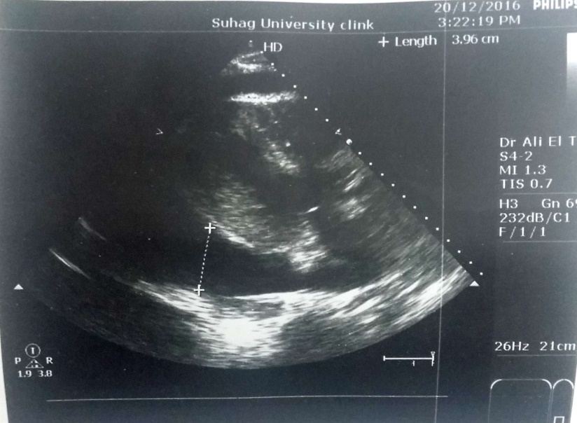
Fig. (1): Transthoracic echo of massive pericardial effusion
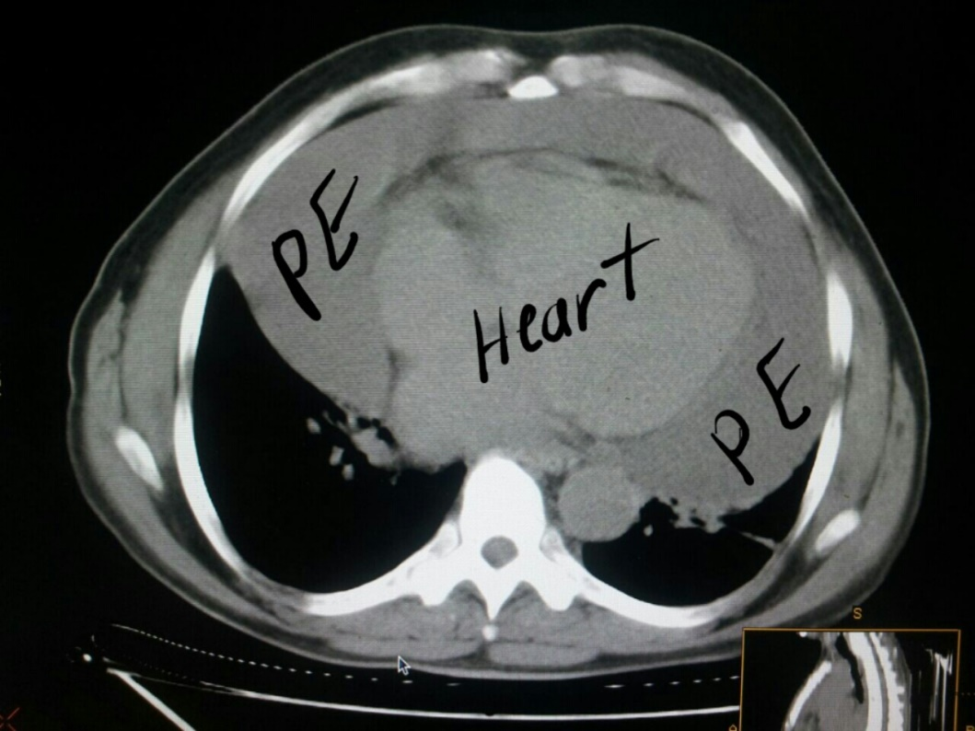
Fig. (2): Computed tomography of chest shows massive pericardial effusion
Procedure:
The procedure was performed under general anesthesia with either double lumen (33 cases) or single lumen (20 cases) intubation, in the supine position with elevation of the chest (45 degrees) in the majority of cases (82%), and lateral decubitus position in the remaining. The endoscopic camera and the other instruments were introduced through three incisions at the level of the fourth and sixth left intercostal spaces. The pleural space and lung were examined first, and any pleural effusion was drained and sent for cytological examination. After the phrenic nerve identification, the distended pericardium was grasped with endoscopic forceps and incised with endoscopic scissors 1-2 cm above and parallel to the phrenic nerve. Pericardial fluid was collected for cytological and microbiological analysis. The cut edges of the pericardial window were treated with electrocautery. The thoracoscopic suction device was used to evacuate the rest of effusion.
A large pericardial opening was created with good protection of the phrenic nerve. A pericardial biopsy was taken and sent for pathological examination (Fig. 3). Two chest tubes were inserted into the pleural cavity, through the two port sites; one of them through the window to drain the pericardium and the other in the left pleural cavity.
Forty tow patients (79%) were extubated on table and transferred to the ward after few hours of observation in the recovery room, while 11 patients (21%) were transferred to the ICU. The chest tube was removed when the amount of daily drainage was <200 ml/day. Antibiotics, analgesics and other specific therapy (according to the etiology) were given to the patients. Follow up echocardiography was done for all cases on discharge and one month after discharge in the outpatient clinic. All cases were subjected to monthly clinical follow up 6 months after discharge.

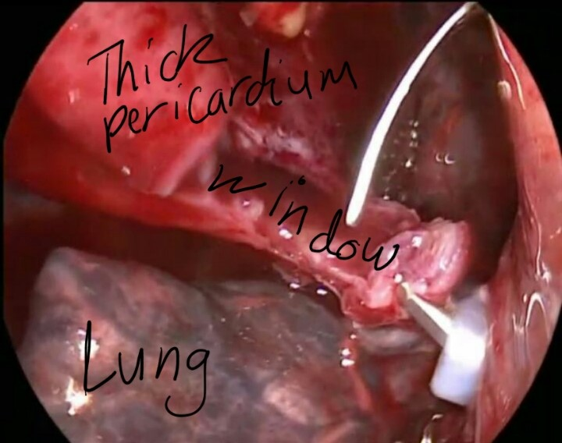
Fig. (3): pericardial window
Results:
Fifty-three patients with massive pericardial effusion (with or without tamponade) were included in the study, 33 males and 20 females, aged from 20 to 55 years (mean 40±8.7 years) (table 1).
The causes of PE are summarized here as follows: lung cancer 7 cases; breast cancer 5 cases; metastatic (unknown primary) 2 cases; esophageal cancer 1 case (all malignant cases were metastatic except 2 cases with direct pericardial invasion from lung and esophageal malignancy); uremia 5 cases; tuberculosis 8 cases; chronic non specific inflammation 13 cases and idiopathic 12 cases (table 1).
The preoperative main clinical presentation was dyspnea in the majority of cases (57%), followed by fever (15%) and chest pain (8%). Four cases (7.5%) were asymptomatic at time of presentation, and 7 cases (13%) were unstable with signs of tamponade (table 1).

Table (1): Preoperative data
Data |  |  | Number | %
Age (yrs) | Mean±SD | 40±8.7
Age (yrs) | Range | 20-55
Sex | Male | 33 |  | 62
Sex | Female | 20 |  | 38
Etiology of PE | Malignancy | 15 |  | 28
Etiology of PE | Tuberculosis | 8 |  | 15
Etiology of PE | Renal failure | 5 |  | 9
Etiology of PE | Purulent | 13 |  | 24
Etiology of PE | Idiopathic | 12 |  | 22.6
Clinical  Presentation | Dyspnea  Emergency | 30  7 |  | 57  13
Clinical  Presentation | Thoracic pain | 4 |  | 8
 | Fever | 8 |  | 15
 | Asymptomatic | 4 |  | 7.5

The amount of pericardial fluid drained averaged 450±95 ml (from 350 to 600 ml). The mean operative time was nearly 2 hours (120.45±34.67 minutes) with a range from 85 to 180 minutes.
Marked improvement in the general condition and clinical presentation occurred in the majority of cases (40 out of 49) (82%), where 4 cases were asymptomatic preoperatively. The improvement was better in patients presented by dyspnea especially in emergency cases. In 6 patients (3 malignant, 2 uremic and one tuberculous) there is mild improvement of dyspnea as they were in terminal stage of their disease. 3 patients with septic PE presented for 2 weeks with fever postoperatively.
Associated pleural effusion was present 10 cases (19%), adhesions between the lung and chest wall was present in 4 cases of them where cutting the adhesions and freeing the lung was done with electrocautery. Accidental lung injury occurred in 5 cases, air leak in 6 cases, transient ventricular arrhythmias in 7 patients, and atelectasis in 5 cases. The mean hospital stay was 9 days (ranged from 5-25 days), and the mean chest tube duration was 4.3 days with a range from 2.5 to 6 days (Table 2).
There were no perioperative deaths. The Thirty-day mortality was 11% (6 patients). Recurrent pericardial effusion occurred in 3 cases (5.6%) (Table 2).

Table (2): Intraoperative and postoperative data
Data |  | Number | %
Operative time  (min) | Mean±SD | 120.45±34.67
Operative time  (min) | Range | 90-165
Amount of fluid drained | Mean±SD | 450±95
Amount of fluid drained | Range | 350-600
Intraoperative and | Bleeding | 5 |  | 9
Postoperative complications | Air leak | 6 |  | 11
Postoperative complications | Cardiac | 7 |  | 13
Postoperative complications | Atelectasis | 5 |  | 9
 | Recurrence | 3 |  | 5.6
Duration of chest tube (days) | Mean±SD | 4.3±1.5
Duration of chest tube (days) | Range | 2.5-6
Hospital stay (days) | Mean±SD | 9±4.04
Hospital stay (days) | Range | 5-25
Mortality | Operative | 0 |  | 0
Mortality | Post operative | 6 |  | 11

Discussion:
Symptomatic PE is a common cardiothoracic presentation. It may reflect a wide variety of causes, ranged from infection to malignancy. When medical treatment fails to control the effusion, surgical intervention is needed. The other main indication of surgical intervention is the need for diagnosis of the cause of the effusion (3).
There are many approaches described for the diagnosis and treatment of PE. These include pericardiocentesis, percutaneous catheter drainage, subxiphoid pericardial drainage and/or fenestration, pericardioperitoneal shunt and pericardial window through anterior thoracotomy/thoracoscopy (8). Pericardiocentesis is associated with high rates of early recurrence and, therefore, has been largely considered as obsolete technique by many authors for the treatment for PE (9).
The two main interventional procedures agreed upon the last decade as the two reasonable options for PE treatment are: surgical (transthoracic or subxiphoid) and video-assisted thoracoscopy (VATS) pericardial window (10). The VATS pericardial window has many advantages over surgical intervention. First, it is less traumatic than anterior thoracotomy, and it allows more extensive pericardial resection compared to the subxiphoid route (8). Second, it allows better visualization than the subxiphoid approach. Third, loculated effusions, specially the posteriorly located effusions which can never be reached without open thoracotomy, are now easily approached by VATS (3).
In our study malignancy accounting only for 28% of cases, while the majority of cases (72%) have a benign etiology, infection, tuberculosis, idiopathic, and uraemia. This is consistent with the study done by Trivino A, etal (11), where the benign processes were the majority of the cases (77.3%) and the malignancy represent 23.7%.
On the other hand, Our results was not consistent with the results of the studies done by both O′Brien et al (2), and Muhammed et al. (3), where they found malignancy was the commonest cause of PE. We explain this by the relative younger mean age of our patients (40 years) in comparison to (44years and 56 years) in their studies, and also to the fact that infections are much commoner in our country.
The mean age of our patients was 40±8.7 years, which is relatively younger than other studies (1-3, 12.13), this because the benign etiology of most of our patients (specially infection), while in other studies malignancy was the commonest cause.
The mean operative time was 120 minutes with a range from 85 to 180 minutes, which was longer than other studies by Muhammed et al (3), and Georghiou et al (8), where the mean operative time was 111minutes and 46 minutes respectively, as this was our initial experience.
All patients tolerated the procedure well; there were no intraoperative or early postoperative major complications related to the procedures. Accidental lung injury with minimal bleeding which stopped spontaneously occurred in 5(9%) cases; air leak occurred in 6 (11%) cases but did not present beyond the 3rd postoperative day; transient ventricular arrhythmias occurred in 7(13%) patients in the early postoperative period but were controlled with lidocaine and did not persist for more than a day, and atelectasis in 5 cases. The mean hospital stay was 9 days (ranged from 5-25 days) and the mean chest tube duration was 4.3 days with a range from 2.5 to 6 days.
There were no perioperative deaths. The Thirty-day mortality was 11% (6 patients). Three patients had malignant pericardial effusion and died of extensive malignancy 20 to 27 days postoperatively. One patient had tuberculous pericarditis and died at 20th day postoperatively. The remaining 2 patients had uremic pericardial effusion. A similar result was seen in the study conducted by McDonald et al., (13) who reported a mortality rate around 13% after VATS. On the other hand, a higher mortality rate was reported in the study published by O'Brien et al., (2) where the 30 day mortality was 60%; which can be explained by the older age group selected by them and the higher malignancy rate of their cases.
Recurrent PE occurred in 3 cases (5.6%) with malignant disease due to extensive lymphoma with pericardial involvement in one patient, and metastasis in the remaining 2 cases.
Conclusion:
Our study concluded that VATS pericardial window is an effective, safe and minimally-invasive technique for PE drainage and taking pericardial, pleural and lung biopsies. We recommend its use instead of open surgery for selected patients with proper indications.

References:
1. Allama AM. Video-assisted thoraciscopic pleuropericardial window for recurrent massive pericardial effusion in patients with known malignancy. Journal of the Egyptian Society of Cardio-Thoracic Surgery 24 (2016)249-254.
2. O'Brien PK, Kucharczuk JC, Marshall MB, Friedberg JS, Chen Z, Kaiser LR, et al. Comparative study of subxiphoid versus video-thoracoscopic pericardial "window". Ann Thorac Surg. 2005;80(6):2013-9.
3. Muhammad MI. The pericardial window: is a video-assisted thoracoscopy approach better than a surgical approach? Interact Cardiovasc Thorac Surg. 2011;12(2):174-8.
4. Mirhosseini SM, Fakhri M, Mozaffary A, Lotfaliany M, Behzadnia N, Ansari Aval Z, et al. Risk factors affecting the survival rate in patients with symptomatic pericardial effusion undergoing surgical intervention. Interact Cardiovasc Thorac Surg. 2013;16(4):495-500.
5. Ng CS, Lau KK, Gonzalez-Rivas D, Rocco G. Evolution in surgical approach and techniques for lung cancer. Thorax. 2013;68(7):681.
6. Gonzalez-Rivas D, Yang Y, Guido W, Jiang G. Non-intubated (tubeless) uniportal video-assisted thoracoscopic lobectomy. Ann Cardiothorac Surg. 2016;5(2):151-3.
7. Apodaca-Cruz A, Villarreal-Garza C, Torres-Avila B, Torres J, Meneses A, Flores-Estrada D, et al. Effectiveness and prognosis of initial pericardiocentesis in the primary management of malignant pericardial effusion. Interact Cardiovasc Thorac Surg. 2010;11(2):154-61.
8. Georghiou GP, Stamler A, Sharoni E, Fichman-Horn S, Berman M, Vidne BA, et al. Video-assisted thoracoscopic pericardial window for diagnosis and management of pericardial effusions. Ann Thorac Surg. 2005;80(2):607-10.
9. Landreneau RJ, Mack MJ, Hazelrigg SR, Naunheim K, Dowling RD, Ritter P, et al. Prevalence of chronic pain after pulmonary resection by thoracotomy or video-assisted thoracic surgery. J Thorac Cardiovasc Surg. 1994;107(4):1079-85; discussion 85-6.
10. Uramoto H, Hanagiri T. Video-assisted thoracoscopic pericardiectomy for malignant pericardial effusion. Anticancer Res. 2010;30(11):4691-4.
11. A.Trivino, F.Cozar, M.Congregado, G. Gallardo, S. Moreno-Moreno, R. Jimenez-Merchan. J. Loscertales. pericardial window by videothoracoscopy. CIR ESP.2011;89(10):677-680.
12. Nataf P, Cacoub P, Regan M, Baron F, Dorent R, Pavie A, et al. Video-thoracoscopic pericardial window in the diagnosis and treatment of pericardial effusions. Am J Cardiol. 1998;82(1):124-6.
13. McDonald JM, Meyers BF, Guthrie TJ, Battafarano RJ, Cooper JD, Patterson GA. Comparison of open subxiphoid pericardial drainage with percutaneous catheter drainage for symptomatic pericardial effusion. Ann Thorac Surg. 2003;76(3):811-5; discussion 6.

